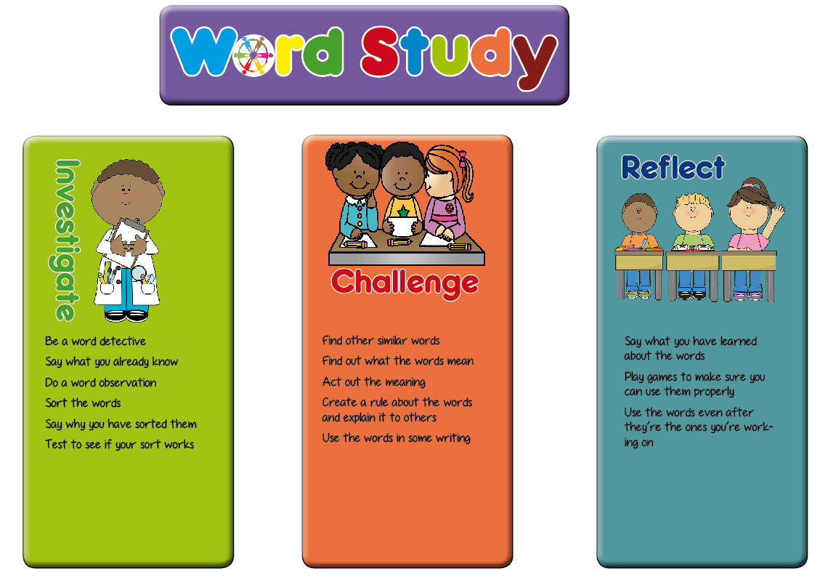**Year 2 Planning Ideas**

In Key Stage One, we have planned a range of generic activities which fit in with the word study teaching sequence. These are a suggestion for ideas which will generate talk for spelling activities and promote enquiry and discussion of the way words work among the pupils.

Hopefully these ideas will be a springboard for the activities you plan in your classroom.

|  |  |  |
| --- | --- | --- |
| **Investigate** | **Challenge** | **Reflect** |
| * Say what they know about the words (modelling) * Soundtalk the words * How many phonemes are there in the word? * Are there long or short vowels in the word? * How many syllables are there in the word? * Look for small words in the whole words * Look at the shape of the words * Look at what the words mean * Do a word sort (see the word sort resources section of the web site) * Say why they have sorted the words in the way they have * Explain what they think the spelling rule sort is | * Explain to someone else how to do the word sort * Finger spy or magnifying glasses to find words that are similar (visit other classes, stuck around the room, in the garden, in their reading books) * Find out what the new words mean (using dictionaries, ask someone at home) * Can you act the words out? * Explain how to use the words * Can you put the words in a sentence? * Can you find other words with the same pattern to add to your word sort? | * Play hangman with the words * Play bingo with words * Play snap with words * Build with magnetic letters (could be timed) * In pairs, take turns to spell the words * Spelling investigation writing – use different colours * Have a poster area for children to add words to the word sort as they find them in their reading |

**This list of tasks for spelling is taken from the planning structure at Shakespeare and More** [**www.shakespeareandmore.com/spelling.html**](http://www.shakespeareandmore.com/spelling.html)

|  |  |  |
| --- | --- | --- |
| **Summer Term Year 2 list** | **Teaching Guidance** | **Word List** |
| **The /i:/ sound spelt –ey** | The plural of these words is formed by the  addition of **–s** (*donkeys*, *monkeys,* etc.). | key, donkey, monkey, chimney, valley, turkey |
| **The /ɒ/ sound spelt a after w and qu** | **a** is the most common spelling for the **/**ɒ**/**  (‘hot’) sound after **w** and **qu**. | Want, watch, wander, quantity, squash |
| **The /ɜ:/ sound spelt or after w** | There are not many of these words. | Word, work, worm, world, worth |
| **The /ɔ:/ sound spelt ar after w** | There are not many of these words. | War, warm, towards |
| **The /ʒ/ sound spelt s** |  | Television, treasure, usual |
| **Homophones and near homophones** | It is important to know the difference in  meaning between homophones. | Bear, bare  One, won  Sun, son  Too, two, to  Be, bee  Blew, blue  Knight, night  there, their, they’re  here, hear  quite, quiet  see, sea |
| **Words ending in –tion** |  | station, fiction, motion, national, section |
| **Contractions** | In contractions, the apostrophe shows  where a letter or letters would be if the  words were written in full (e.g. *can’t* –  *cannot*).  *It’s* means *it is* (e.g. *It’s* raining) or  sometimes *it has* (e.g. *It’s* been raining),  but *it’s* is never used for the possessive | Can’t, won’t, didn’t, couldn’t, it’s, I’ll |
| **The possessive apostrophe**  **(singular nouns)** |  | the girl’s, the boy’s, Katie’s, Ahmed’s, the child’s, the man’s |
| **Common exception words** | Could, should, would, who, whole, any, many, clothes, busy, people, door, floor, poor, because, find, kind, mind, behind, child, children, wild, climb, most, only, both, old, cold, gold, hold, told, every, everybody, even, great, break, steak, pretty, beautiful, after, fast, last, past,, father, class, grass, pass, plant, path, bath, hour, move, prove, improve, sure, sugar, eye, could, should, would, who, whole, any, many, clothes, busy, people, water, again, half, money, Mr, Mrs, parents, Christmas | |